William B. Silver was born in Pilesgrove, Salem County, New Jersey, on 14 Feb 1808. His birth was chronicled in the Woodstown Friends Monthly Meeting minutes, where his parents’ William Silver and Rebecca Bates were members. In 1827, the Silver family was granted a Quaker Certificate of Removal recommending them to Springborough Monthly Meeting in the State of Ohio. The Silver family followed William’s older brother, Samuel, who had been received by the meeting on January 25, 1825. The family travelled the 580 mile trip to Ohio, in a covered wagon. Their first cabin was a simple wooden structure.

William B. Silver married Ann Johnson, on 30 Sep 1835, at Warren, Ohio, at the Miami Meeting house. Ann and her family were also Quakers and had originally lived in Stanton, Delaware. After they married, they moved to Preble County, Ohio and were received by the Westfield Monthly Meeting. William B. and Ann lived for many years in Dixon Township, in Preble County, Ohio. William B. owned eight hundred acres of land and was a farmer. He also had a side occupation as one of the first salesman for the McCormick Reaper Company.

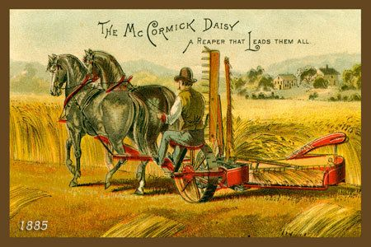

On May 15, 1864, two of William B. and Ann’s sons, Oscar and Joshua, mustered out as Union soldiers, for the 156th Regiment, Ohio Infantry (National Guard). Which went against the basic Quaker tenant of pacifism. Many felt pressure to volunteer, because of the Federal Conscription Laws. If they refused to serve, they could be fined, have their property confiscated or possibly jailed. Many of the Quaker community did volunteer. Some of the meetings read out these individuals, while others looked the other way. After the war ended, most of them were reinstated in their meetings without discipline.

Well before the advent of the Civil War, Quakers in Ohio and Indiana, were caught up in the abolitionist movement. The major routes of the Underground Railroad passed through the area in which the Silver family lived. There are no records found that identified them as active participants in the effort, but they certainly were aware of the existence of the Underground Railroads.

On April 28, 1869, William B. Silver, his wife, Ann Johnson, and their youngest children, Robert (Direct-line Descendant) and Rebecca Ann, were granted a certificate to the White Water Monthly Meeting (Hicksite), in Richmond, Indiana. They continued to live there until March 28, 1883. At that time they returned to Preble County, Ohio and rejoined the Westfield Monthly meeting. They were received on certificate by the White Water Monthly Meeting.

In 1888, William B. and Ann moved to Kansas City, Wyandotte County, Kansas. They were living with their daughter’s family, Rebecca Ann Silver and Winfield Freeman, at 606 Freeman Avenue. William B. Silver died on 11 Dec 1893. He is buried at the Oak Grove Cemetery, 419 Haskell Avenue, in Kansas City, Kansas. Ann died on 15 Sep 1895, in Kansas City, Kansas and is buried in the same cemetery.